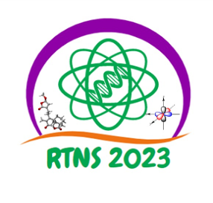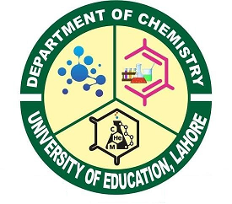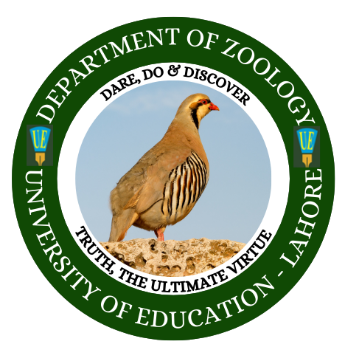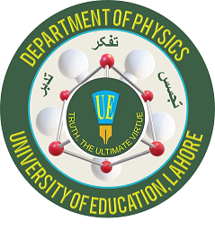 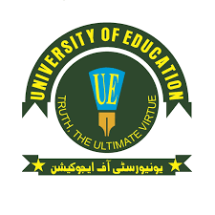

2nd International Conference on

**Recent Trends in Natural Sciences (RTNS 2023)-Hybrid**

**3-4 May, 2023**

|  |  |
| --- | --- |
| Patron in Chief :  Prof. Dr. Talat Naseer Pasha (H.I., S.I.)  Vice Chancellor  University of Education, Lahore |  |
| Patron:  Prof. Dr. Muhammad Arshad  Pro-Vice Chancellor  University of Education, Lahore |  |
| Co-Patron:  Prof. Dr. Muhammad Alam Saeed  Director,  Division of Science & Technology |  |
| Co-Patron:  Prof. Dr Muhammad Ikram Ullah  Principal Jauharabad Campus |  |
| Conference Chair:  Dr. Sajad Hussain  Chairman Department of Physics, |  |

**Invited Speakers for RTNS 2023**

|  |  |
| --- | --- |
| **Name & Affiliation** | **Picture** |
| **Dr. Li Wang**  Associate Prof.  Institute of Nuclear and New Energy Technology, Tsinghua University, Beijing,  P. R. China. |  |
| **Prof. Dr. Honggyun Kim**  Department of Semiconductor System Engineering, Sejong University, Seoul, South Korea. |  |
| **Dr. Naveed Hussain**  Senior Research Fellow, Department of Electrical Engineering and Computer Sciences, Henery Samueli school of Engineering, University of California Irvine, United States |  |
| **Nardin AVISHAN**  Quantum Devices and Nanophotonics Research Laboratory Electrical and Electronics Engineering Department Middle East Technical University 06800 Ankara, Turkey |  |
| **Dr. Muhammad Nauman**  ESPRIT Fellow Thermodynamics of quantum materials laboratory (TQM) Institute of Science and Technology Austria (ISTA) |  |
| **Dr. Khurram Shehzad**  Associate Professor of Research, Zhejiang University, Yuquan campus, 310027, Hangzhou, China. |  |
| **Dr. Zafar Wazir**  Associate Professor/Chairperson  Department of Physics,  Ghazi University Dera Ghazi Khan. |  |
| **Dr. Waheed S. Khan**  Dy. Chief Scientist Group Leader of Nanobiotechnology Research Group NIBGI National Institute of Biotechnology and Genetic Engineering, Faisalabad. |  |
| **Dr. Ghulam Nabi**  Tenured Associate Professor  Department of Physics  University of Gujrat  Gujrat |  |
| . **Dr. Asif Ilyas**  Assistant Professor,  Department of Physics  Faculty of Sciences,  PMAS Arid Agriculture University Rawalpindi, |  |
| **Dr. Nawishta Jabeen**  Assistant Professor,  Department of Physics,  Fatima Jinnah Women University Rawalpindi |  |
| **Dr. Ahmad Hussain**  Assistant Professor,  Department of Physics,  University of Lahore Sargodha Campus.  . |  |

|  |  |
| --- | --- |
| **Caitlin J. Risener**  Medical Ethnobotanist,  Emory Winship Cancer Institute,  Emory University Atlanta, GA, USA |  |
| **Prof. Dr. Zeliha Selamoglu**  Department of Medical Biology  Faculty of Medicine  Nigde Ömer Halisdemir University  Campus 51240 Türkiye |  |
| **Dr. Shamim Akhter**  Professor of Zoology  Pir Mehr Ali Shah Arid Agriculture University Rawalpindi-46300, Pakistan |  |
| **Dr. Farooq Ahmed Jam**  Executive Director  Global illuminators  Kuala Lumpur Malaysia |  |
| **Dr Imrana Amir**  Assistant Professor  Department of Zoology,  University of Mianwali |  |
| **Dr. Ammara Riaz**  Assistant Professor  Department of Life Sciences  Faculty of Natural and Applied Sciences  Khwaja Fareed University of Engineering and Information Technology Rahimyar Khan |  |
| **Dr. Abdul Ghani**  Associate Professor of Botany  University of Sargodha, Sargodha |  |
| **Dr. Iqra Parvez**  Chairperson Biological Sciences  Superior University  Mandi Bahauddin Campus |  |
| **Dr. Umair Ahmad Khan**  Assistant Professor of Botany University of Lahore Sargodha Campus |  |
| **Mr Wajahat Ameer**  Deputy Director fisheries  Government of Punjab, Chashma Mianwali |  |
| **Dr Nagina Rehman**  Assistant Professor  Department of Zoology, University of Mianwali, Mianwali. |  |
| **Dr. Sana Ashraf**  Associates professor  University of Lahore Sargodha campus |  |
| **Dr. Sunbal Khalil**  Associates professor/ Head Institute of Molecular Biology & Biotechnology  University of Lahore Sargodha campus |  |
| **Dr. Asif Naseem**  Assistant Professor of Zoology  University of Lahore Sargodha Campus |  |
| **Dr. Kashif Hanif**  Assistant Professor University of Lahore Sargodha campus |  |
| Dr Abdul Rauf Raza  Professor Chemistry  Institute of Chemistry, Ibn e Sina Block,  University of Sargodha, Sargodha | https://su.edu.pk/upload/department/faculty/profiles/Abdul_Rauf_Raza.JPG |
| Assist. Prof. Dr. Mehmet Fatih SAĞLAM  Gebze Technical University, Faculty of Science  Department of Chemistry, Gebze, Kocaeli, TURKEY | C:\Users\Laila\Downloads\WhatsApp Image 2022-05-12 at 6.47.55 PM.jpeg |
| Dr Ashraf Shaheen  Professor Chemistry  Institute of Chemistry, Ibn e Sina Block,  University of Sargodha, Sargodha, Pakistan | https://su.edu.pk/upload/department/faculty/profiles/Dr_Shaheen.jpg |
| Dr Humaira Yasmeen Gondal  Associate Professor Chemistry  Institute of Chemistry, Ibn e Sina Block,  University of Sargodha, Sargodha, Pakistan | https://su.edu.pk/upload/department/faculty/profiles/Humaira_Yasmeen_Gondal.JPG |
| Dr M. Fayyaz Ur Rahman  Lecturer Chemistry  Institute of Chemistry, Ibn e Sina Block,  University of Sargodha, Sargodha, Pakistan | https://su.edu.pk/upload/department/faculty/profiles/513116.jpg |
| Dr. Giovanni F. Caramori  Professor  Department of Chemistry, Federal University of Santa Catarina, Brazil | People – Molecular Electronic Structure Group |
| Dr. Matthias Lein  Senior Principal Data Engineer  Alexander Thamm, GmbH, Germany | C:\Users\yasir\OneDrive\Desktop\matthias-lein.1024x1024.jpg |
| Dr. Muhammad Naeem Ahmed  Professor  Department of Chemistry  The University of Azad Jammu and Kashmir, Muzaffarabad, AJK | C:\Users\yasir\OneDrive\Desktop\download.jpg |
| Dr. Saqib Ali  Assistant Professor,  Department of Chemistry,  University of Kotli, AJK | University of Kotli Azad Jammu and Kashmir |